Phynart DSL Engagement

# About Phynart

Phynart is a home automation company providing Smart Home platform and devices. The platform controls and monitors the home appliances in a secure ecosystem.

### Product offerings

* U.F.O – the core of the platform where all the transformations for different devices, protocols happen
* Smart plug device – for high power appliances like AC, geyser
* Switch board device – for low power appliances like lights, fan
* LED device – controls level, color of the LED light
* Multi-sensor device – measures temperature, humidity, intrusions, light, presence etc.
  + New feature – measure body temperature of people 7-10 feet apart

# Points of discussion

## Device agnostic platform

A particular system device only works with its specific system application. This makes it a closed platform.

With the number of devices increasing rapidly, there is a need to have an operating system which has the ability to talk to all the different devices in a location.

Phynart is developing its open platform.

## Higher levels of Automation

The current situation is that the user triggers devices locally or remotely via a client application. Although manual intervention to control devices is greatly reduced, this process is not completely automated. User intervention is still a strong input.

Total or very high automation would be achieved when the devices automatically change their status based on insights gained from historical preferences of a particular user. This brings in the idea of recommending configurations to a user for a device.

# Our understanding of the flow of events

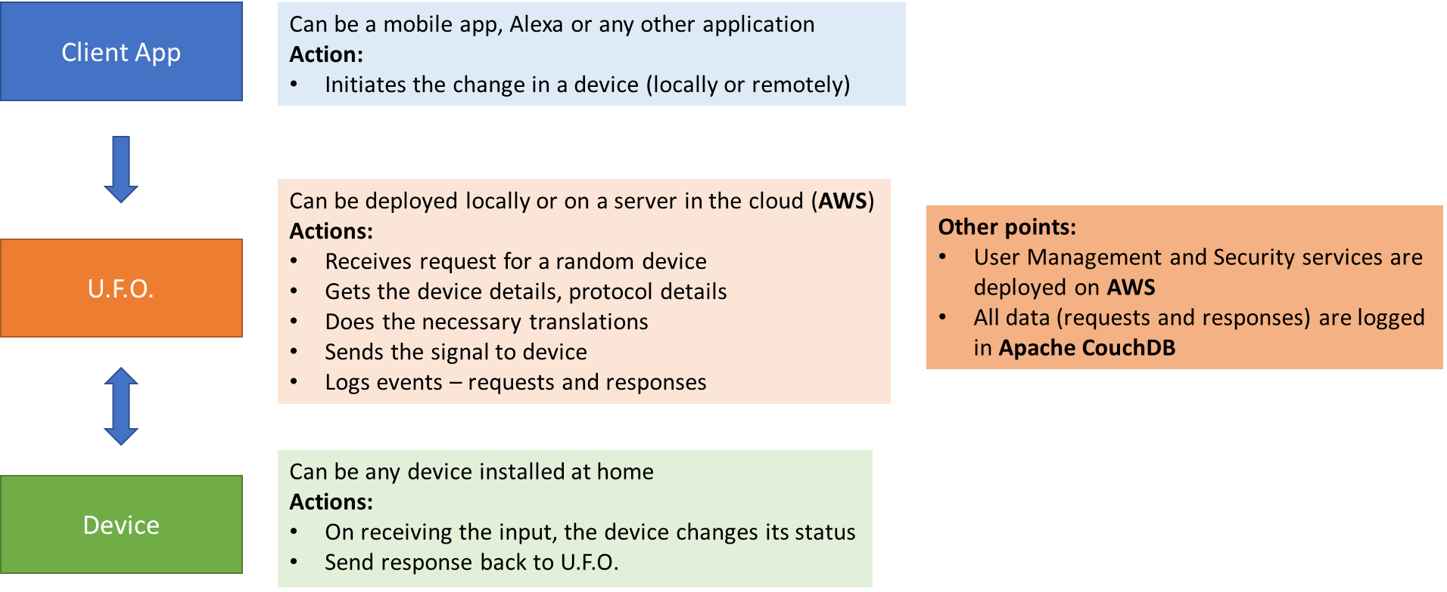

## High level flow diagram – provided by Phynart

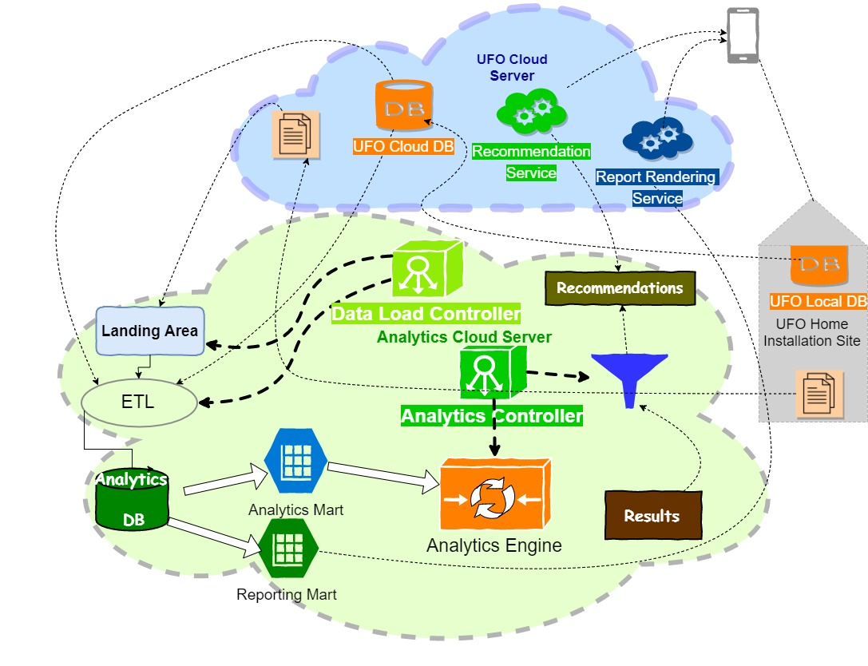

# Some Notes

* U.F.O. has an internal memory of **64GB**. As of now it is adept in holding the data generated from the devices for a long duration of time.
  + 4-5 users in a house having 15 IoT devices generate a maximum of **8-10GB** of data for a year, as of now.
* Most of the Smart Home protocols are supported by U.F.O (*Wi-Fi, Zigbee, Z-Wave, etc.*)
* Users, rooms and devices can be modified through an Admin interface.
* Types of devices as per documentation shared:
  + Dimmable – Bulb, Fan
  + NonDimmable – Tube, LEDBulb, CFL
  + Curtain – Drapery or RollerBlind
  + LED – LEDStrip
  + PowerSocket – Microwave, TV, Fridge
  + MotionAndLightSensor
* Actuation Schema

Actuation Schema – shared by Phynart

DSL involvement

DSL comes in to contribute to the 2nd point of discussion – **Higher levels of Automation**.

Based on the **historical** data for a particular user’s **interaction** with a device, in accordance with other attributes (like time, day of the week, etc.), we need to **analyze** the data and build a **personalized** **recommendation** for the user for that particular device.

# Steps

1. **Data Preparation**
   1. Being a domain specific input, we have requested Phynart to give us the data in some format – csv file, tabular etc.
   2. This data would basically be the requests and responses recorded in the audit trails for every user.
2. **Understanding the data**
   1. Know the different devices
   2. Identify the affected columns during request for a device
   3. Identify the affected columns during response by a device
   4. Identify relationship between columns
3. **Data Checks**
   1. Validity Check – We will need to consult with Phynart to decide on the data validity
   2. Missing Values and Outlier identification
4. **Data Analysis**
   1. Missing Values and Outlier treatment
   2. Data visualization
   3. Data transformations
5. **Data Modelling**
6. **Recommendation**
7. **Model Deployment**
   1. Model Docker container creation
   2. Deployment on Edge (U.F.O.)
8. **Model Performance Monitoring**

## Output

The output of the engagement is to provide a recommended configuration for a user for a device.

# Short Term Goal

* Building an analytics pipeline which will consist of following:
* Pulling data from CouchDB
* Doing time bucketing based on "On-Off" actuation and if time and data permits (stretch goal), based on "level" and "color settings"
* Provide a function, which will be deployed on edge device
* Function will do descriptive analytics and output table with time bucketing

# Predictive/Prescriptive analytics related stories will be taken up after December 2020.

# References

## Actuation Schema

{

"actuationId": "1955298325",

"type": "actuations",

"locationId": "5211244101",

"userName": "bob",

"requestTime": "2020-09-03T11:08:25.759378+00:00",

"intent": "powerController",

"url": "zigbee://Phynart/Aurora/00000000ABC54321/13",

"requestId": "xxxx-yyyy-aaaa-bbbbb",

"commands": [

{

"command": "on",

"arguments": []

}

],

"responseTime": "2020-09-03T11:20:54.689308+00:00",

"status": {

"code": 200,

"message": "device action success"

},

"states": {

"powerState": "on",

"level": 100,

"hue": 150,

"sat": 200,

"musicSync": "off"

},

"device": {

"productId": "5f338f3b5ecd784d2fd09ef0",

"manufacturerName": "Phynart",

"productType": "LED Strip",

"deviceId": "1219914113",

"macAddress": "00000000ABC54321",

"derivedType": "slots",

"deviceName": "Led Strip",

"productName": "Aurora",

"capabilities": [

{

"capabilityName": "powerController",

"displayName": "On Off Control"

},

{

"capabilityName": "percentageController",

"displayName": "Level Control"

},

{

"capabilityName": "colorController",

"displayName": "Color Control"

},

{

"capabilityName": "musicSyncController",

"displayName": "Music Sync Control"

}

],

"parentDeviceId": "6c611aeb2c3142359e87c21dc9555c62",

"supportedProtocols": [

"zigbee"

],

"url": "zigbee://Phynart/Aurora/00000000ABC54321/13",

"deviceInfo": {},

"supportedDevices": [

"Led Strip"

],

"deviceTypeName": "Led Strip",

"room": {

"roomId": "1760894445",

"roomName": "Guest Room",

"roomTypeName": "Guest Room",

"isPrivate": false

},

"configuredCapabilities": [

{

"capabilityName": "powerController",

"displayName": "On Off Control"

},

{

"capabilityName": "percentageController",

"displayName": "Level Control"

},

{

"capabilityName": "colorController",

"displayName": "Color Control"

},

{

"capabilityName": "musicSyncController",

"displayName": "Music Sync Control"

}

]

}

}